PAMS 2009 Booth Registration

SUMMARY
- Booth Exhibition will be available from Tuesday, October 13th through Thursday, October 15th (3 days)
- Booths will open at 1:00PM and close at 3:30PM
- Booths will be located in the 2nd and 3rd floor lobbies of the Main Hall 'Hae' of the National Theater of Korea

REGISTRATION AND FEE PAYMENT METHOD
○ Booth Allocation
- Registrants may select desired location(s) of booth(s) depending on availability
- Booth rentals will be processed on a first-come-first-served basis (approximately 83 booths available for rental)
- Individual groups may select up to 4 booths each
* Please inquire separately beforehand if you are selecting more than 2 booths.
○ Booth Registration
  - Online Registration: Complete the registration form available online at PAMS homepage (http://www.pams.or.kr ). The registration fee must be paid online with a credit card*.
* Online Payments can be made only after installing the Active X control in the MS Internet Explorer Environment.
  - Offline Registration: If you choose not to make an online payment via credit card, please download and fill out the registration form, then send it with a copy of your bank payment receipt via E-mail to registration@pams.or.kr, or Fax it to +82-(0)2-745-3139

Bank (wire) transfer information
Account name: Korea Arts Management Service
Bank & Address: WOORI BANK, HYEHWADONG BR.
132-1, Hyehwa-dong, Jongno-gu, Seoul, Korea
Swift Code: HVBKKRSE
Account number: 1005-001-483973

○ Registration Period
  - Registration opens at 10:00AM (Korean Time), August 10, 2009
  - Registration closes at 6:00PM (Korean Time), September 10, 2009

○ Booth Registration (Rental) Fee
Category | Registration Fee
General Registration | KRW300,000

○ Offerings (based on a single booth unit rental)
  - Booth: 1 unit
  - Table: 1 unit
  - Chairs: 2 units
  - Electric (Power) Outlet: 1 unit
  - Exhibitor Tags: 2 (to be carried at all times to enter the Booth Exhibition)
※Please inquire separately if you need an A/V equipment rental.

CANCELLATIONS AND REFUNDS
○ All requests for cancellation of registration must be made in writing via email. Please send your requests for cancellation to registration@pams.or.kr.
○ Cancellation penalties will be applied based on the date that the cancellation request is processed.

※ For inquiries regarding registration please contact:
registration@pams.or.kr
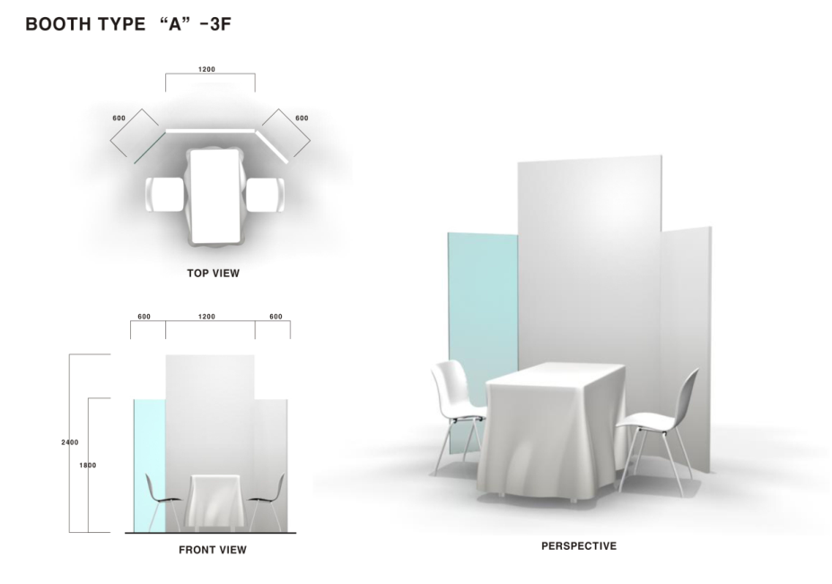
Tel. +82 2 745 3862 Fax +82 2 745 3139
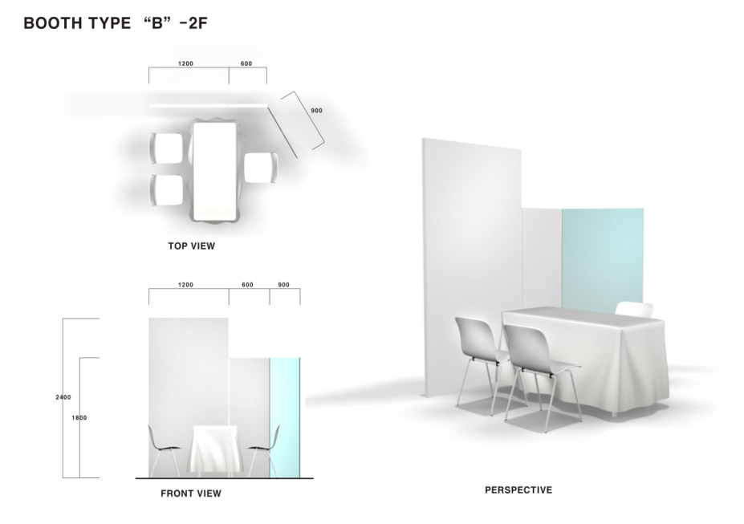
※ Both Booth types offer two chairs only.
PAMS 2009 Booth Registration Form

A. Booth Registration Form

a. General Group/Organization Information
Name of Applying Group/Organization

Representative of Applying Group/Organization

Address
City |  | state
Country |  | postal code
telephone |  | Fax
Email
Website
Booth Stand Type | ☐ Performance Groups ☐ Associations ☐ Organizational Institutes  ☐ Venues ☐ Foundations ☐ Festivals ☐ Others
Booth Stand Type | ☐ Theatre ☐ Dance ☐ Music ☐ Multi-disciplinary
Booth Introduction for the program book | (※100~200 words)
Photo for the program book | Please, attach a photo that represents your group
Q’ty of Booth(s) | ☐ 1 ☐ 2 ☐ 3 ☐ 4
Desired location  Booth number  (Offline registration  only) | Select five preferred booth numbers from the plan below.  ex) 2F- 2, 3F-44….
Booth Layout
2nd Floor Lobby – Main Hall ‘Hae’
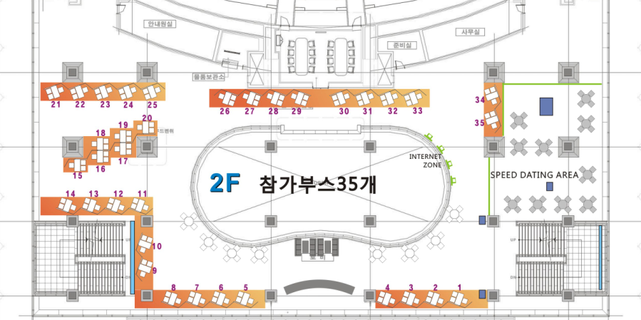
Total of 35 Booths
3rd Floor Lobby – Main Hall ‘Hae’
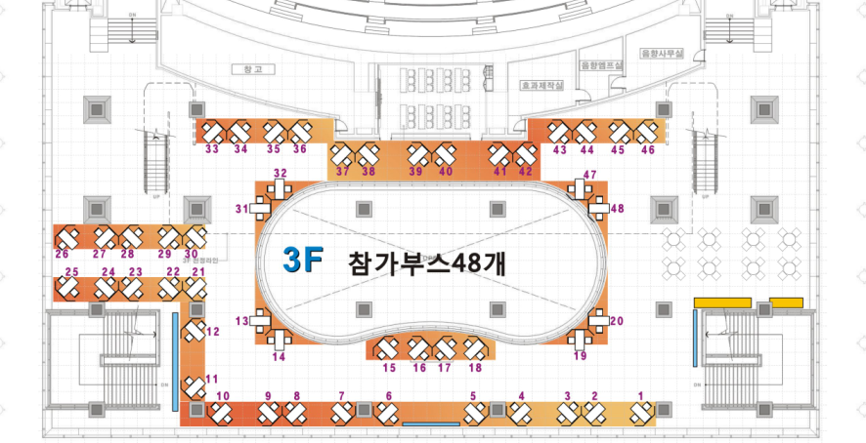
Total of 48 Booths

b-1. General Information (registrant 1)
name ◻ Mr. ◻ Ms. (First Name) (Last Name)
Main activities of participant
◻ presenter (artistic director/programmer) ◻ promoter ◻ producer ◻ administrator ◻ artist ◻ journalist ◻ consultant ◻ professor ◻ researcher ◻ student
◻ other (please specify):
Date of Birth
job title
Area of interest
◻ theatre ◻ music ◻ dance ◻ multidisciplinary
◻ other (please specify):
Address
City | State
Country | postal code
telephone | fax
Email
Website

c. book your seat!
‘Round Table’ is a program designed to promote networking and the exchange of information between artists and professionals from each continent. This program is open to a limited number of participants, on a subscription basis.

program | total
Round Table* | ◻Western Europe ◻Eastern Europe ◻Asia & Oceania  ◻ Central & South Americas

B. Visitor Blurb for PAMS 2009 All-guide

a. purpose
This section is to gather the information that will be distributed to participants in PAMS 2009.

b. information
Please attach your photo (300dpi minimum) in jpg file format and submit it along with an introduction of your purpose for visiting PAMS 2009, your field of work, your interests, and any other relevant information. Please limit your self-introduction to 100 words.

photo | Purpose, field of work, interests, etc.

b-2. General Information (registrant 2)
name ◻ Mr. ◻ Ms. (First Name) (Last Name)
Main activities of participant
◻ presenter (artistic director/programmer) ◻ promoter ◻ producer ◻ administrator ◻ artist ◻ journalist ◻ consultant ◻ professor ◻ researcher ◻ student
◻ other (please specify):
Date of Birth
job title
Area of interest
◻ theatre ◻ music ◻ dance ◻ multidisciplinary
◻ other (please specify):
Address
City | state
Country | postal code
telephone | Fax
Email
Website

c. book your seat!
‘Round Table’ is a program designed to promote networking and the exchange of information between artists and professionals from each continent. This program is open to a limited number of participants, on a subscription basis.

program | total
Round Table* | ◻Western Europe ◻Eastern Europe ◻Asia & Oceania  ◻ Central & South Americas

B. Visitor Blurb for PAMS 2009 All-guide

a. purpose
This section is to gather the information that will be distributed to participants in PAMS 2009.

b. information
Please attach your photo (300dpi minimum) in jpg file format and submit it along with an introduction of your purpose for visiting PAMS 2009, your field of work, your interests, and any other relevant information. Please limit your self-introduction to 100 words.

photo | Purpose, field of work, interests, etc.
b-3. General Information (registrant 3)
*Fill out only if you are registering more than one booth
name ◻ Mr. ◻ Ms. (First Name) (Last Name)
Main activities of participant
◻ presenter (artistic director/programmer) ◻ promoter ◻ producer ◻ administrator ◻ artist ◻ journalist ◻ consultant ◻ professor ◻ researcher ◻ student
◻ other (please specify):
Date of Birth
job title
Area of interest
◻ theatre ◻ music ◻ dance ◻ multidisciplinary
◻ other (please specify):
Address
City | State
Country | postal code
telephone | Fax
Email
Website

c. book your seat!
‘Round Table’ is a program designed to promote networking and the exchange of information between artists and professionals from each continent. This program is open to a limited number of participants, on a subscription basis.

program | total
Round Table* | ◻Western Europe ◻Eastern Europe ◻Asia & Oceania  ◻ Central & South Americas

B. Visitor Blurb for PAMS 2009 All-guide

a. purpose
This section is to gather the information that will be distributed to participants in PAMS 2009.

b. information
Please attach your photo (300dpi minimum) in jpg file format and submit it along with an introduction of your purpose for visiting PAMS 2009, your field of work, your interests, and any other relevant information. Please limit your self-introduction to 100 words.
photo | Purpose, field of work, interests, etc.
b-4. General Information (registrant 4)
*Fill out only if you are registering more than one booth
name ◻ Mr. ◻ Ms. (First Name) (Last Name)
Main activities of participant
◻ presenter (artistic director/programmer) ◻ promoter ◻ producer ◻ administrator ◻ artist ◻ journalist ◻ consultant ◻ professor ◻ researcher ◻ student
◻ other (please specify):
Date of Birth
job title
Area of interest
◻ theatre ◻ music ◻ dance ◻ multidisciplinary
◻ other (please specify):
Address
City | state
Country | postal code
telephone | fax
email
website

c. book your seat!
‘Round Table’ is a program designed to promote networking and the exchange of information between artists and professionals from each continent. This program is open to a limited number of participants, on a subscription basis.

program | total
Round Table* | ◻Western Europe ◻Eastern Europe ◻Asia & Oceania  ◻ Central & South Americas

B. Visitor Blurb for PAMS 2009 All-guide

a. purpose
This section is to gather the information that will be distributed to participants in PAMS 2009.

b. information
Please attach your photo (300dpi minimum) in jpg file format and submit it along with an introduction of your purpose for visiting PAMS 2009, your field of work, your interests, and any other relevant information. Please limit your self-introduction to 100 words.
photo | Purpose, field of work, interests, etc.

